Date:

TASK 5: CNOT Gate and Quantum Teleportation

Aim: To simulate a CNOT gate and implement a simplified quantum teleportation protocol using Qiskit.

1 Mathematical Model of the CNOT Gate

The CNOT (Controlled-NOT) gate is a two-qubit quantum gate that flips the target qubit if and only if the control qubit is in state ∣1 .

Computational basis ordering: ∣00 ,∣01 ,∣10 ,∣11 with first qubit = control(q0), second qubit = target(q1).

1.1 Matrix Representation

The CNOT gate is represented by the following unitary matrix
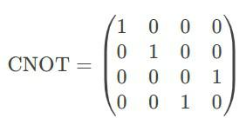

1.2 CNOT Gate Truth Table
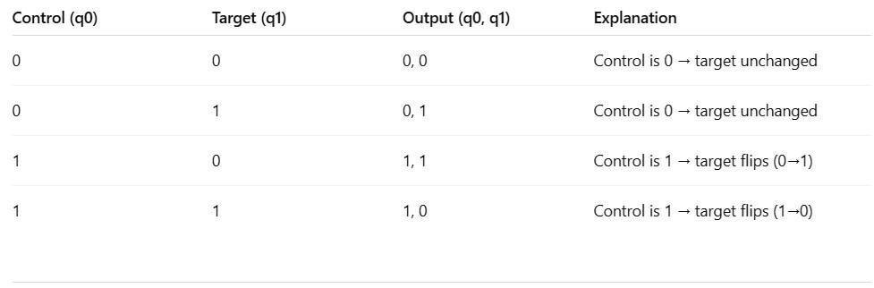

1.3 Effect on Basis States

If control = |0 , target remains unchanged. If control = |1 , target flips (X-gate applied).
2 Algorithm for CNOT Gate Implementation

- Initialize a quantum circuit with 2 qubits and 2 classical bits.

- Prepare input states (e.g., test all possible combinations: |00 , |01 , |10 , |11 ).

- Apply CNOT gate (control qubit = q0, target qubit = q1).

- Measure the qubits and store results in classical bits.

- Simulate the circuit using Qiskit’s Aer simulator.

- Plot the measurement outcomes.

3 Program

from qiskit import QuantumCircuit from qiskit_aer import Aer
from qiskit.visualization import plot_histogram import matplotlib.pyplot as plt

def cnot_circuit(input_state):
"""
Creates and simulates a CNOT circuit for a given input state.

Args:
input_state (str): '00', '01', '10', or '11'
"""
qc = QuantumCircuit(2, 2) # 2 qubits, 2 classical bits

# Prepare input state
if input_state[0] == '1':

qc.x(0) # Set q0 to |1
if input_state[1] == '1':

qc.x(1) # Set q1 to |1

- Apply CNOT (q0=control, q1=target) qc.cx(0, 1)

- Measure qubits

qc.measure([0, 1], [0, 1])

# Simulate
simulator = Aer.get_backend('qasm_simulator')
result = simulator.run(qc, shots=1000).result()
counts = result.get_counts(qc)

# Plot results

print(f"\nCNOT Gate Test | Input: |{input_state} ")
print("Circuit Diagram:")
print(qc.draw(output='text'))
plot_histogram(counts)
plt.show()

# Test all possible inputs
for state in ['00', '01', '10', '11']:
cnot_circuit(state)

4. Mathematical Model for Quantum Teleportation

Quantum teleportation enables transferring an unknown quantum state from Alice to Bob using:

- Entanglement (shared Bell pair)

- Classical communication (2 bits)

- Quantum operations (CNOT, Hadamard, measurements)

4.1 Initial Setup

Alice has qubit

Alice and Bob share an entangled Bell pair
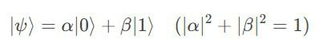
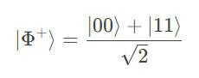

4.2 Step-by-Step State Evolution

- Combined state

- Alice applies CNOT (q0 → q1)
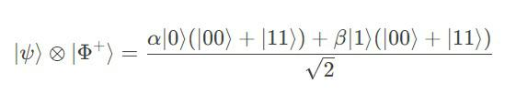
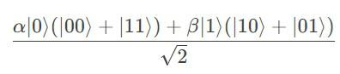

- Alice applies Hadamard to q0

- Alice measures q0 & q1 → gets one of 4 classical outcomes (00, 01, 10, 11)

- Bob applies corrections

- 00: Do nothing

- 01: Apply X gate

- 10: Apply Z gate

- 11: Apply X then Z

Final state at Bob's qubit
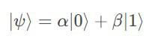

5 Algorithm for Quantum Teleportation Implementation

- Initialize 3-qubit circuit (Alice's q0, shared q1, Bob's q2) + 2 classical bits

- Prepare Alice's qubit (e.g., |1 via X gate)

- Create Bell pair between q1 & q2 (H + CNOT)

- Teleportation protocol

o CNOT(q0, q1) o H(q0)
o Measure q0 & q1 → store in classical bits

- Bob's corrections

o Apply X if c1=1 o Apply Z if c0=1

- Verify by measuring Bob's qubit

6 Program for Quantum Teleportation Implementation

from qiskit import QuantumCircuit from qiskit_aer import Aer
from qiskit.visualization import plot_histogram import matplotlib.pyplot as plt

# Create circuit
qc = QuantumCircuit(3, 2) # 3 qubits, 2 classical bits
- Step 1: Prepare Alice's state (|1 for demo) qc.x(0) # Comment out to teleport |0 qc.barrier()

- Step 2: Create Bell pair (q1 & q2)

qc.h(1)
qc.cx(1, 2)
qc.barrier()

- Step 3: Teleportation protocol qc.cx(0, 1)
qc.h(0)

qc.barrier()

- Step 4: Measure Alice's qubits qc.measure([0,1], [0,1]) qc.barrier()

- Step 5: Bob's corrections qc.cx(1, 2) # X if c1=1 qc.cz(0, 2) # Z if c0=1

- Step 6: Measure Bob's qubit

qc.measure(2, 0) # Overwrite c0 for verification

- Draw circuit print("Teleportation Circuit:") print(qc.draw(output='text'))

- Simulate

simulator = Aer.get_backend('qasm_simulator')
result = simulator.run(qc, shots=1000).result()
counts = result.get_counts(qc)

# Results
print("\nMeasurement results:")
print(counts)
plot_histogram(counts)
plt.show()

Output:
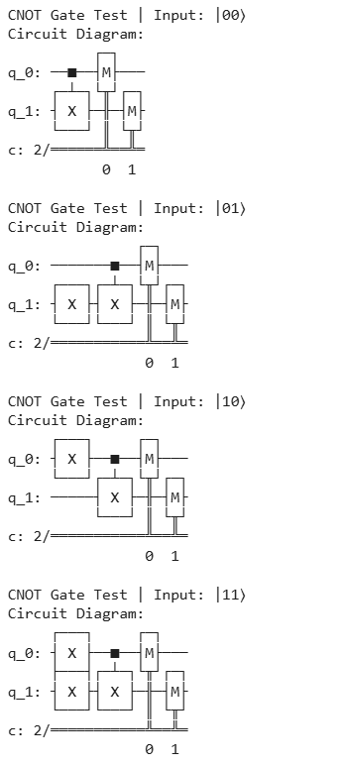

7. Result

This work illustrates the implementation, simulation, and verification of the CNOT gate using Qiskit, followed by the construction of a complete quantum teleportation protocol. The protocol is validated through simulation, confirming the accurate transfer of an arbitrary quantum state using entanglement and classical communication.

